Parallel Remove-Resource Groups using Azure Automation Runbook

Choose an Authentication Type
The runbook works with both an AAD Credential (Automation Credential) and an AAD Service Principal (Automation Connection). The AAD Service Principal is a preferred option as it uses certificate authentication instead of a password that may expire or change more frequently.

Create Azure Automation connection asset
The easiest way to create a new Service Principal connection is to do so when creating a new Azure Automation resource.

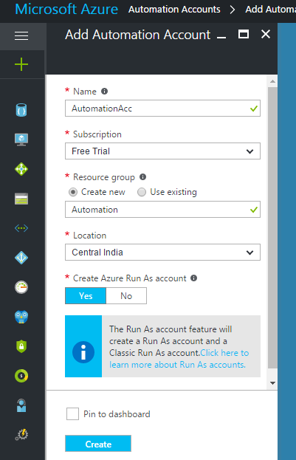

Once the Automation Account is created, click on Runbooks to create a new Runbook.

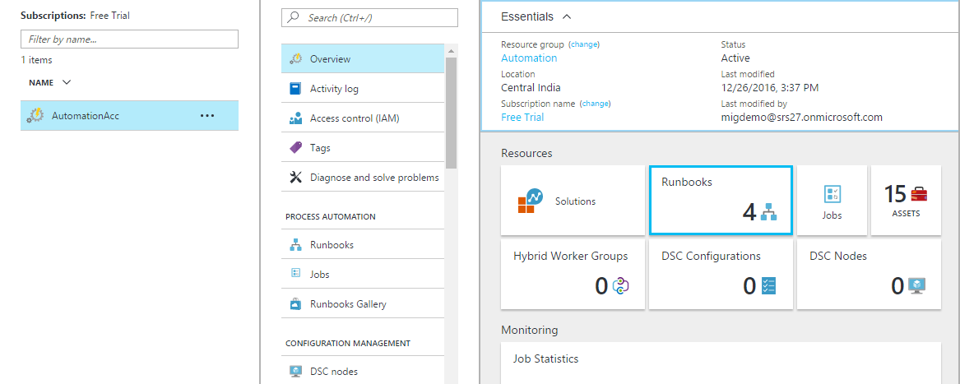
Click Runbooks

Add runbook
Add Runbook

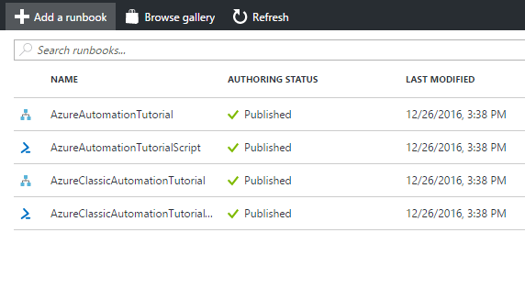

Add Runbook details and click create.
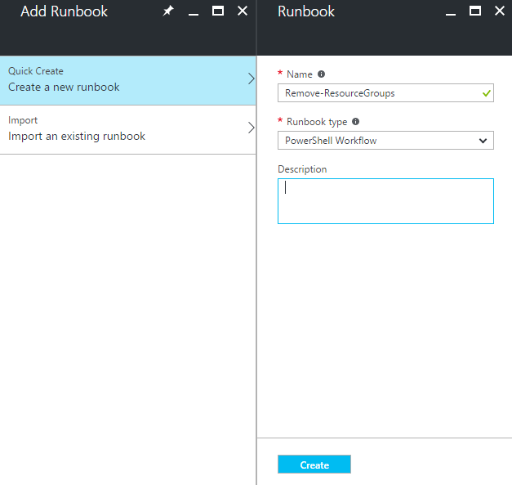

Once the Runbook is created, add the code in the PowerShell workflow window.
Add or Import the Following Attached Runbook
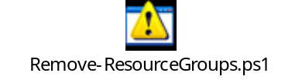
To import the Runbook in Azure
Click on Add Runbook and choose the 2nd option (Import an existing runbook)

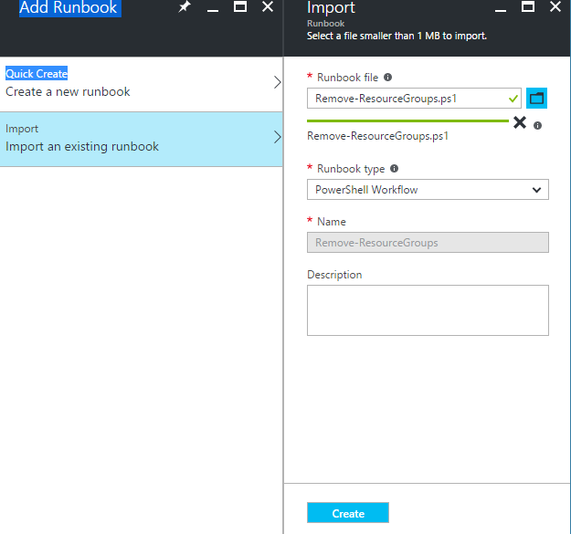

Save and Publish the runbook
To execute this runbook, navigate to the Runbooks tab of your Automation Account, and click on the Remove-ResourceGroups runbook. Click Schedules.
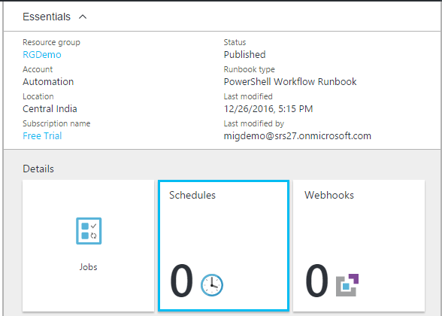
Click on Schedules

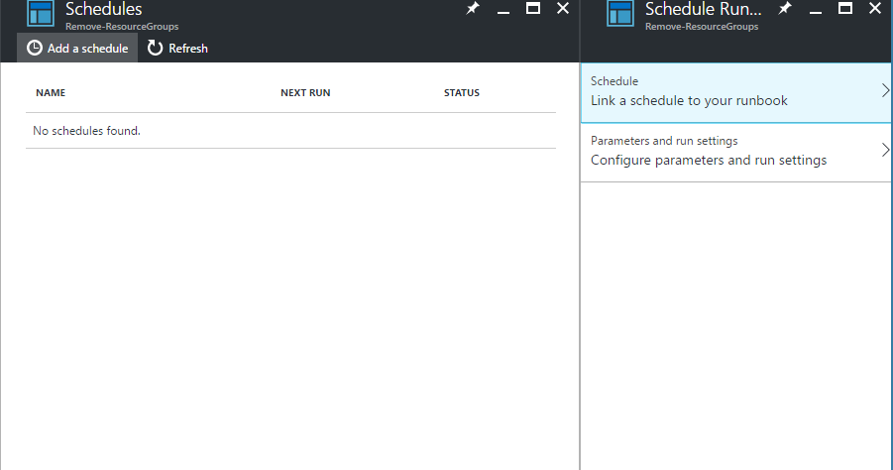

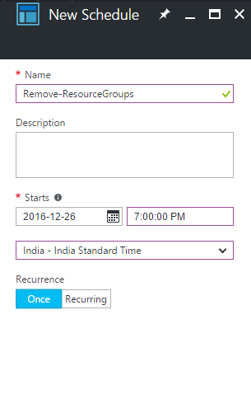
Add a Name for the Schedule
Select on which date this schedule should run
Select on What time this Schedule should run automatically
After the Schedule is created, Configure the parameters and run settings
You will be prompted to fill out a form. Here we will use the following parameters. Notice, you can enter multiple subscriptions and resource groups using comma separated lists. In order to ensure the desired resource groups will be deleted, it is recommended to always test the runbook with PREVIEWMODE set to true.

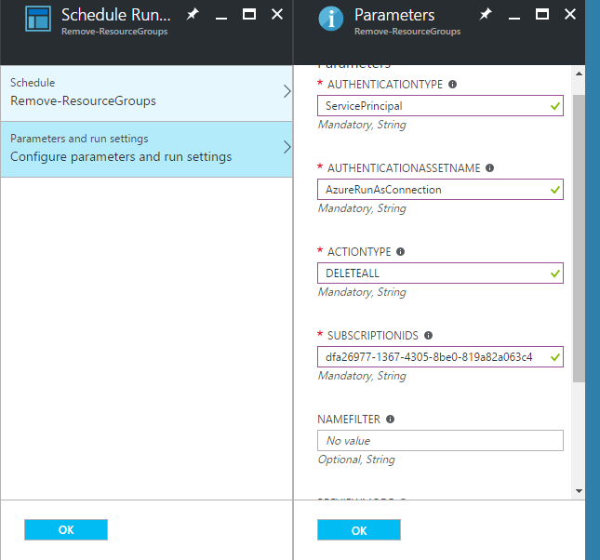
$AuthenticationType = ServicePrincipal
$AuthenticationAssetName = AzureRunAsConnection
$ActionType = DELETEALL
$SubscriptionIDs = (put your Subscription Ids)
PreviewMode =FALSE

Click Ok and Your Schedule Will be Saved.

Note
Make sure Previewmode is set to true to avoid deleting the selected resource groups.
After you have configured all the parameter values, click OK, and the runbook will be queued for execution.

To Run the script manually:
To view the details of the Remove-ResourceGroup runbook job in the Azure portal, select Jobs in the runbook. The job summary displays the input parameters and the output stream in addition to general information about the job and any exceptions that occurred.
Click on Start
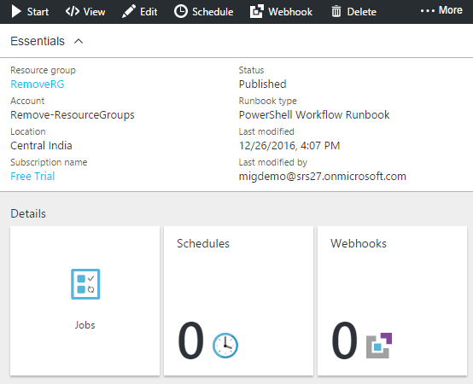
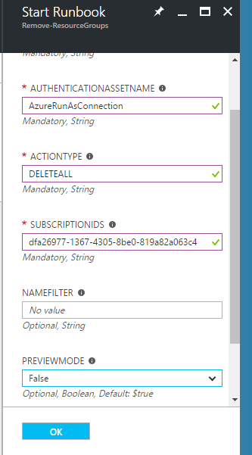
Add the Parameters and Click OK
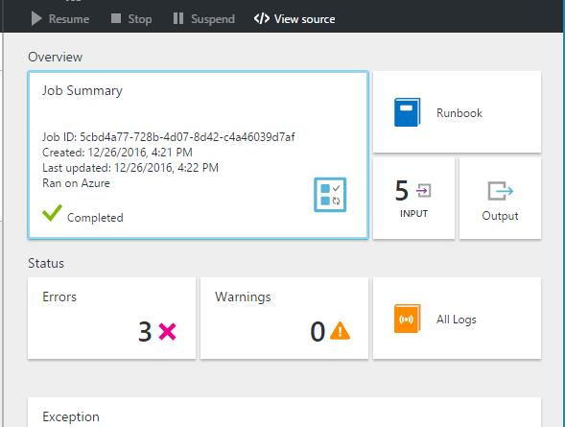
To see the Result Click on Output

The Job Summary includes messages from the output, warning, and error streams. Select Output to view detailed results from the runbook execution.
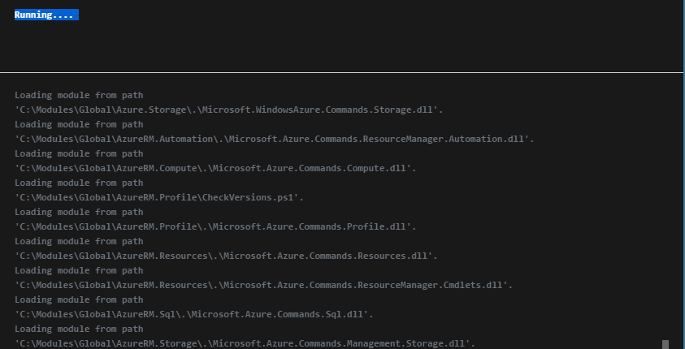

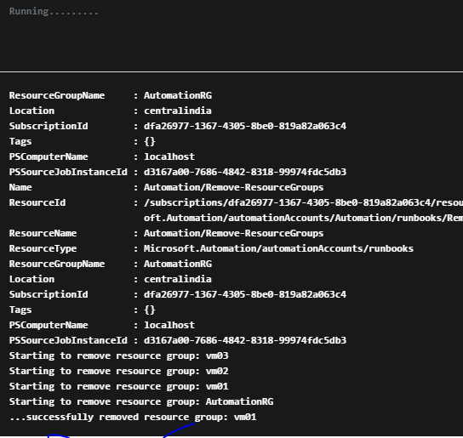

Note: This Script would delete all the resource Groups including the Automation Scripts.

